Server Installation
Docker CE- refer here https://docs.docker.com/engine/install/rhel/
Portainer CE - refer here https://docs.portainer.io/start/install-ce/server/docker/linux
https://10.23.205.104:9443
user: admin
pass: *****
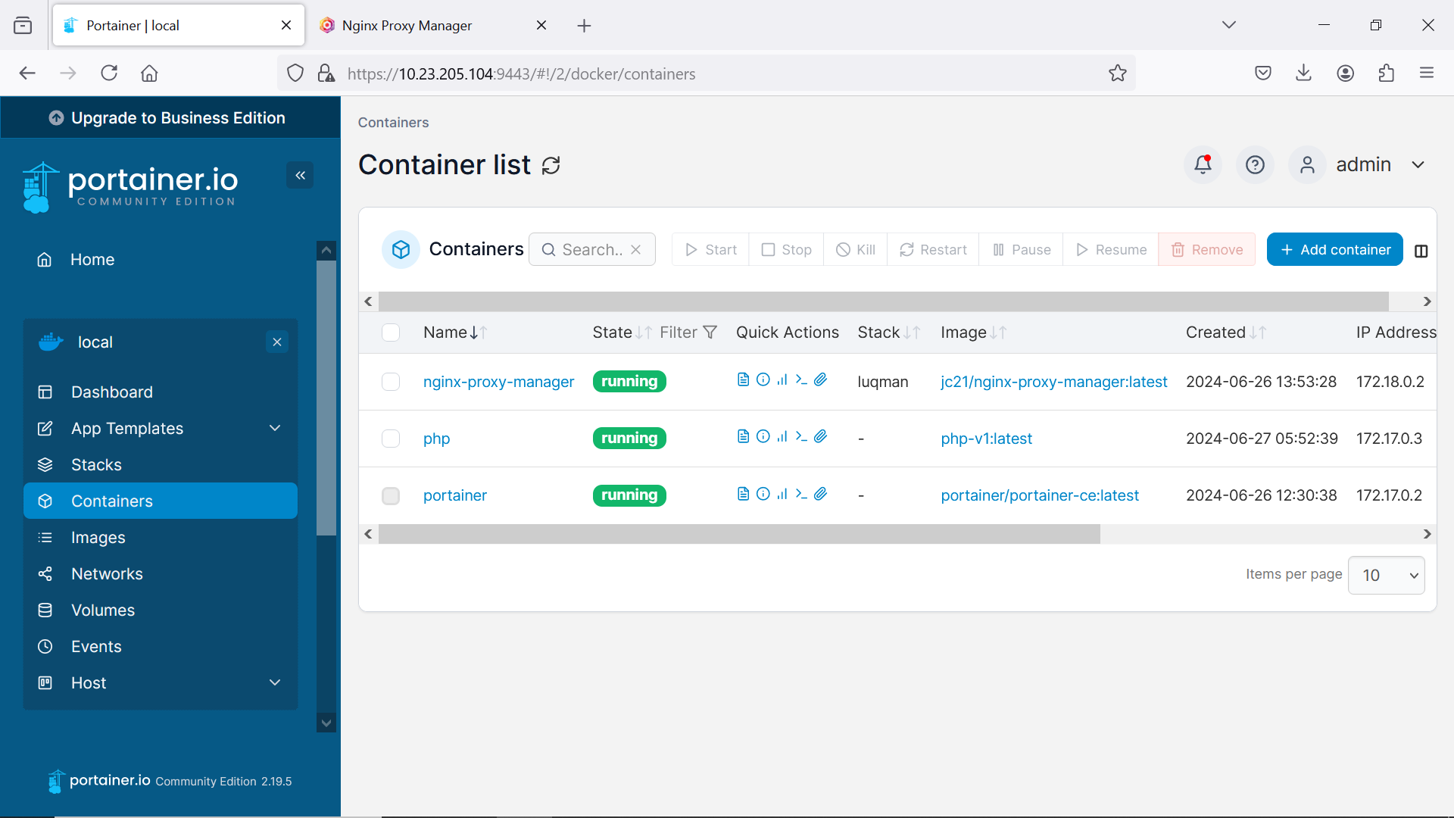
NGINX Proxy manager – manage SSL, domain name to pointing to docker container proxy
user : Luqman.anordin@gmail.com
pass: U53r_4cc0un7
php – Server Application for Apache2, multiple php FPM
login server 10.23.205.104
Server php installation (php container)
#docker exec -it php bash
#sudo apt-get install software-properties-common -y
#sudo add-apt-repository ppa:ondrej/php
#sudo apt-get update -y
#sudo apt-get install php8.0 php8.0-fpm php8.0-ldap php8.0-sqlite3 php8.0-bcmath php8.0-bz2 php8.0-cli php8.0-common php8.0-curl php8.0-dev php8.0-gd php8.0-igbinary php8.0-imagick php8.0-imap php8.0-intl php8.0-mbstring php8.0-memcached php8.0-msgpack php8.0-mysql php8.0-opcache php8.0-pgsql php8.0-readline php8.0-redis php8.0-ssh2 php8.0-soap php8.0-tidy php8.0-xml php8.0-xmlrpc php8.0-zip -y
#sudo service php8.0-fpm start
#sudo apt-get install apache2 libapache2-mod-fcgid -y
#sudo a2enmod actions fcgid alias proxy_fcgi
#sudo a2enmod rewrite
#sudo a2enmod proxy
#sudo a2enmod proxy_fcgi
#sudo a2enmod headers
#sudo service apache2 start
Service need to up if server down
#service docker restart/start/stop
#docker start portainer
Up container using portainer GUI
After container php is up and running, ssh inside container.
ssh into container php, use sudo if not root
#docker exec -it php bash
#service apache2 restart/start/stop
#service php8.0-fpm restart/start/stop
#service php8.1-fpm restart/start/stop
#service php8.2-fpm restart/start/stop
path for Apache and web app file configuration
/var/lib/docker/volumes/php-etc/_data/apache2 - /etc/apache2
/var/lib/docker/volumes/php /var/www/html
Apache use port 8080:80 .
to access without domain : http://10.23.205.104:8080/<subdirectory-web-app>
use https://github.com/cakephp/cakephp/releases/tag/2.10.24
final maintenance release for 2.x. support "php": ">=5.3.0,<8.0.0"
To use cakephp in subdirectory, please adjust apache in
/var/lib/docker/volumes/php-etc/_data/apache2/sites-available/web/<nama app>.conf
copy that file and code inside <related name> need to change according to app name too.
refer template webapp.conf-template
after update please refresh apache2 inside docker (container)
# service apache2 restart

